

CZ4046 INTELLIGENT AGENTS
ASSIGNMENT 2 REPORT

Name: Bhatia Ritik
Matriculation Number: U1822529C
Tutorial Group: CS4

SCHOOL OF COMPUTER SCIENCE AND ENGINEERING
ACADEMIC YEAR 2021/22

Contents
1. Problem 3
1.1. Overview 3
1.2. Some observations 4
2. Considerations 5
3. Strategy Implementation 6
3.1. Always Defect (Nasty Player) 6
3.2. Tolerant Tit-for-Tat 7
3.3. History Rectification 8
3.4. Selected Strategy 9
4. Results 13
4.1. Process to judge performance 13
4.2. Performance of NastyPlayer strategy 14
4.3. Performance of Tolerant Tit-for-Tat strategy 14
4.4. Performance of History Rectification strategy 15
4.5. Performance of selected strategy 16
5. Conclusion 18

Problem

Overview
The Prisoner’s Dilemma is a paradox in decision analysis in which two individuals acting in their own self-interests does not result in the optimal outcome. However, it can also be described as a thought experiment that depicts why individuals may choose to defect (not cooperate) even if it appears beneficial for both parties involved in the process, to do so.
The reason for it being a dilemma is that individual rational action is to defect which guarantees a higher worst payoff than by cooperating. However, intuition suggest that best outcome is that both agents should cooperate and get an even higher payoff. This is what makes the problem interesting, and for this assignment, we are given a slightly modified version of the problem.
In this game, we are given the Three Player Repeated Prisoner’s Dilemma problem. This means that we have three players instead of two, and multiple rounds will be played repeatedly, which makes the lack of cooperation disappear and instead favors agents with smart strategies. More precisely, in our problem, three agents will play a match of 100 rounds each and the ranking is decided by computing the average reward of the game.
The Payoff Matrix for the same is shown below:
Our agent | Opposing Agent 1 | Opposing Agent 2 | Payoff
Cooperate | Cooperate | Cooperate | 6
Cooperate | Cooperate | Defect | 3
Cooperate | Defect | Cooperate | 3
Cooperate | Defect | Defect | 0
Defect | Cooperate | Cooperate | 8
Defect | Cooperate | Defect | 5
Defect | Defect | Cooperate | 5
Defect | Defect | Defect | 2
The reward from each game can be determined from the set of actions chosen by each agent in each round, by using the above Payoff Matrix.
The goal is to devise a strategy that can result in the best ranking possible. Each strategy will be given a history of actions of the agent itself as well as the history of actions of the opponents.

Some observations
A strategy in a repeated game specifies what action the agent should take in each stage of the game, given all the actions taken by all players in the past. There are infinitely many possible strategies, but there are a few popular ones that perform well in a general scenario.
For example, Tit-for-Tat is a strategy that works very well in the two-player Prisoner’s Dilemma. The strategy is simple – the agent starts off by cooperation to show goodwill and then repeats whatever the opponent did in the last round. This means cooperation of opponent is rewarded with cooperation while defection is appropriately punished with a consequent defection.
Another strategy is soft majority where the agent continues to cooperate as long as the number of times the opponent has cooperated is greater than or equal to the number of defections that it has done.
The above show one of the best results in empirical tests in a two-player Prisoner’s Dilemma. However, the main concern for our given problem is whether these (and other well-known strategies) work equally well when three players are involved. Further, the Tit-for-Tat strategy aims to tie the game instead of aggressively trying to beat the opponent/s and gain maximum payoff. Similar shortcomings can be found in other well-known strategies and given the nature of evaluation of our strategy (competition with other strategies); it is favorable to devise a custom strategy for maximum payoff.
Nevertheless, using these well-known strategies is a very good starting point. In devising my custom strategy, I have built off of these strategies in an attempt to gain best the rankings.

Considerations
Some basic assumptions that can be taken for such an environment are:
- Agents are self-interested: they have a preference over how the environment is.
- Agents will not necessarily choose the rational choice (due to the above assumption) and hence our agent should be exploitative when given the opportunity.
- The scenario is highly competitive, however, a strictly competitive / zero-sum strategy will not be the best assumption, as per Axelrod’s suggestions.
- It is impossible to estimate the strategy of the opponents since there are infinitely many strategies possible.
- Due to multiple rounds, if a certain agent defects, it is still possible to recover cooperation through goodwill.
The above assumptions are extremely important to design the agent that can yield an optimal payoff throughout the tournament. Each design decision has its trade-offs; however, the win is by achieving the best balance.
To design the most optimal agent, I took Axelrod’s rules into account which can be summarised as follows:
- Don’t be envious – Don’t play as if the environment is zero sum.
- Be nice – Start by cooperating and reciprocate cooperation
- Retaliate appropriately – Always punish defection immediately, but use measured force (don’t overdo the punishment as one might risk other’s defections which might not be optimal for us)
- Don’t hold grudges – Always reciprocate cooperation immediately
From the above suggestions as provided by Axelrod, it is clear that the strategy of my agent would be such that is relatively fair – if other agents cooperate, it will attempt to cooperate as well (except certain edge scenarios such as the last round of the game where defection can help achieve an even higher payoff) and will punish opponents if they defect. However, retaliation would be measured to avoid entering into a defection loop and it will not hold grudges as it may again risk entering the defection loop since opponents would be doubtful of my agent’s intention to cooperate.
The final consideration is to extend Axelrod’s suggestions to our three-player repeated Prisoner’s Dilemma such as retaliating harshly only if both opponents defect etc.

Strategy Implementation
To find the best strategy, I implemented a few well-known strategies to gauge their performance and to iteratively use them as building blocks to get the next best strategy.
A few strategies that I worked with, before finding the selected strategy are explained in the sections below.

Always Defect (Nasty Player)
Let’s have a look at the Payoff Matrix, sorted by Payoff, below:
Our agent | Opposing Agent 1 | Opposing Agent 2 | Payoff
Defect | Cooperate | Cooperate | 8
Cooperate | Cooperate | Cooperate | 6
Defect | Cooperate | Defect | 5
Defect | Defect | Cooperate | 5
Cooperate | Cooperate | Defect | 3
Cooperate | Defect | Cooperate | 3
Defect | Defect | Defect | 2
Cooperate | Defect | Defect | 0
From the above table, it is very intuitive to see the dominance of defection to get a high payoff and hence, the first strategy that I tested was when the agent always defected (nasty player).
However, this strategy did not perform well (covered in detail in Section 4.) and instead ended up at the bottom of the ranking for the majority of the time. The main reason for this is that if the agent always defects, it is very easy for the opponents to figure that this agent is extremely selfish. Hence, they too defect in the subsequent rounds which leads to a much lower payoff of 2 (as can be seen from the table above).
Therefore, always defection is not a viable strategy to secure a good rank in this problem.

Tolerant Tit-for-Tat
Tit-for-Tat is a very popular strategy that gives great results in the two-player Prisoner’s Dilemma (proven in several research papers). It provides a great balance between cooperation and defection by appropriately punishing the opponent if it defects.
To adapt to the modified three-player Prisoner’s Dilemma, I implemented a tolerant version of this strategy, that is, my agent would defect only if the total number of defections of both agents is greater than the total number of time both agents cooperated. This is done to avoid an aggressive strategy that risks opponents defecting continuously in subsequent rounds.
The code implementation of this strategy is given in Figure 1 below:
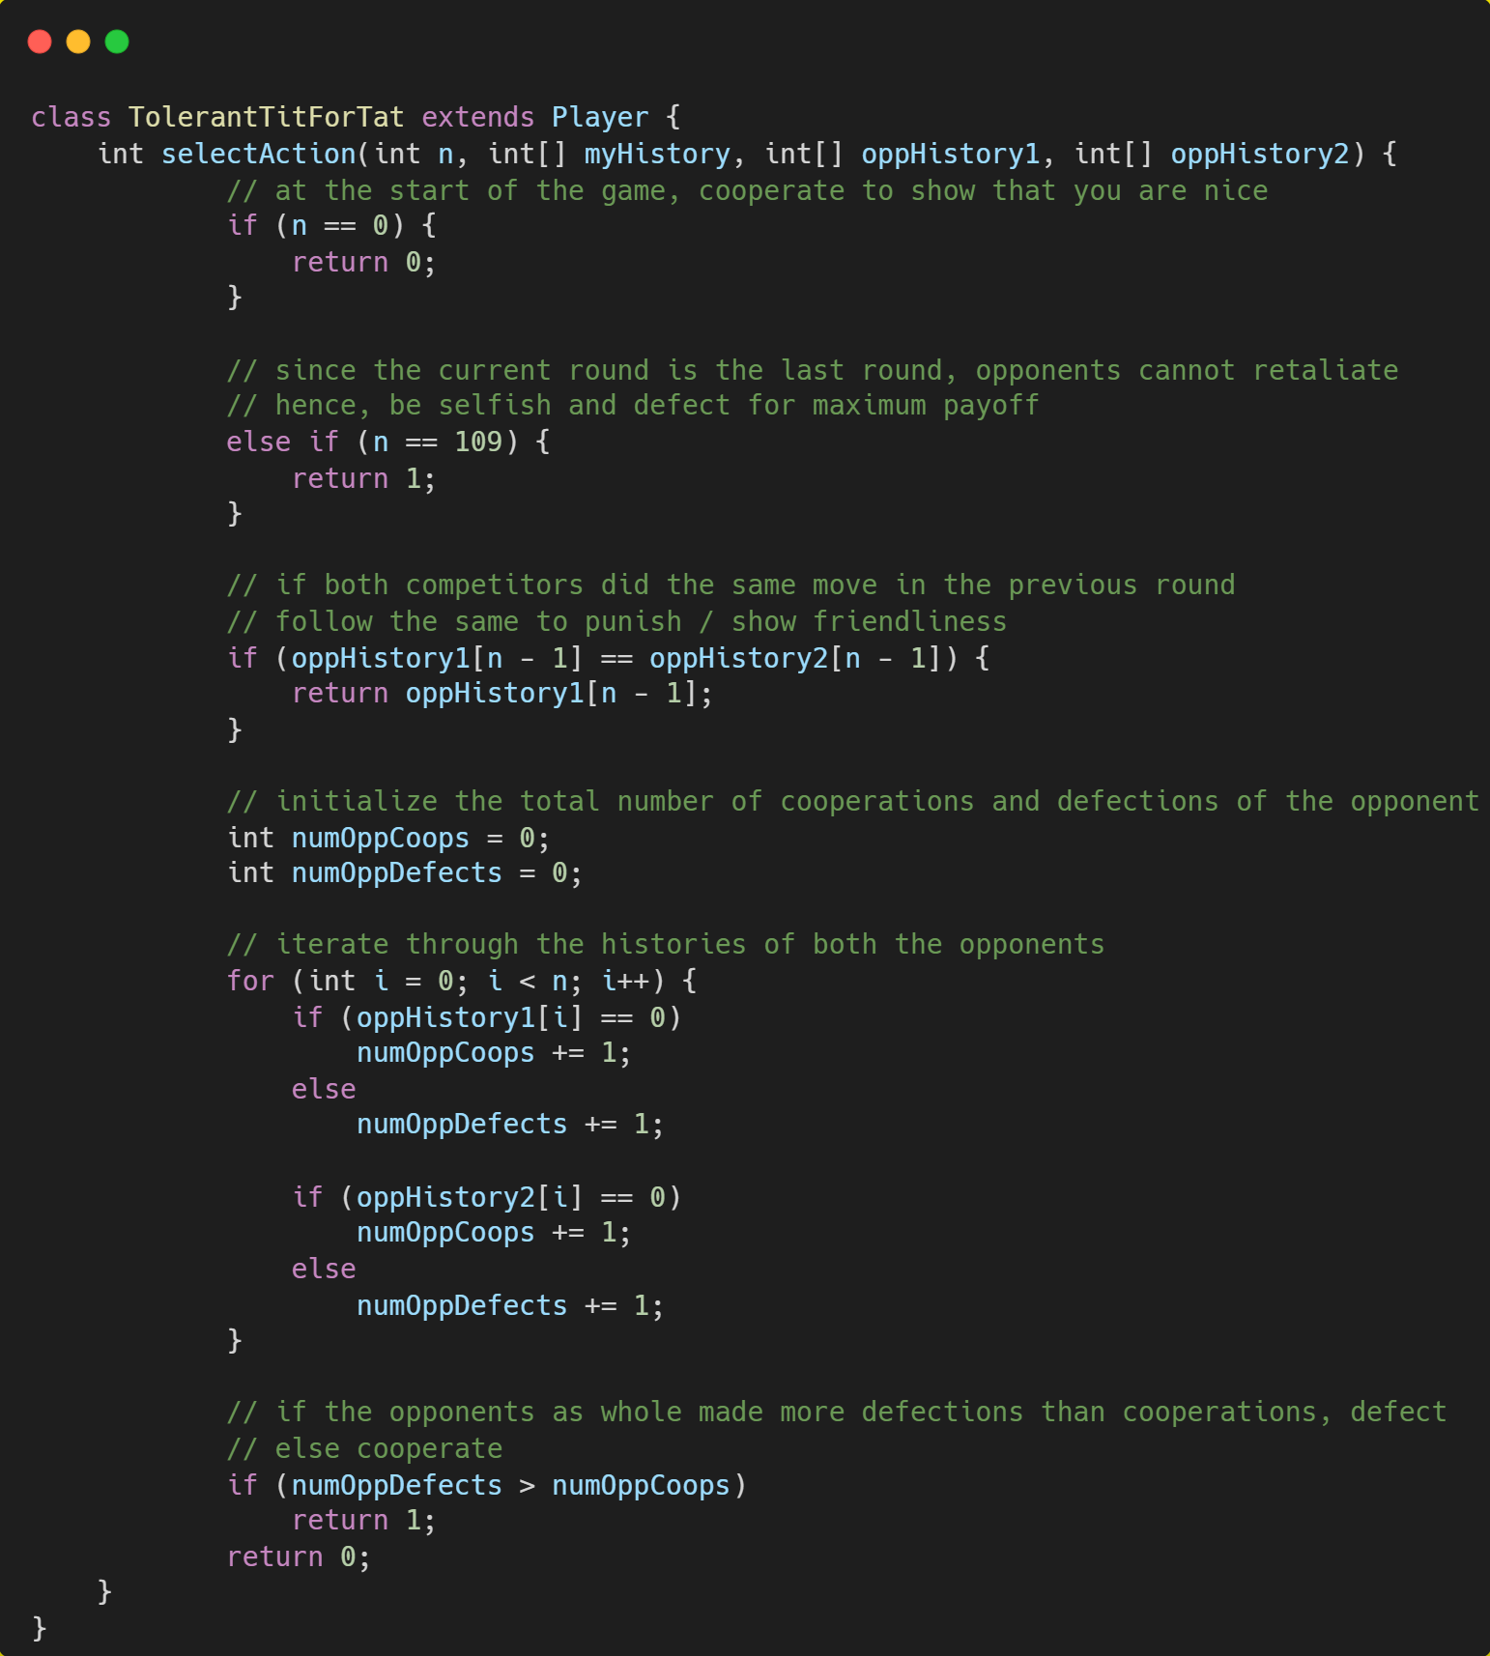
Figure 1. Code for tolerant Tit-for-Tat

History Rectification
Another strategy that I tested was History Rectification. In this strategy, unlike Tit-for-Tat, the agent looks through its own history of actions as well and compares it to that of the opponents’. During comparison, if the agent notices that is has made more defections in the past than both the opponents, then it cools down by cooperating in the current round, otherwise it defects. The cool-down period attempts to express goodwill towards opponents to get them to cooperate in the subsequent rounds while gaining greater payoff through defections in other scenarios.
The code implementation of this strategy is shown in Figure 2 below:
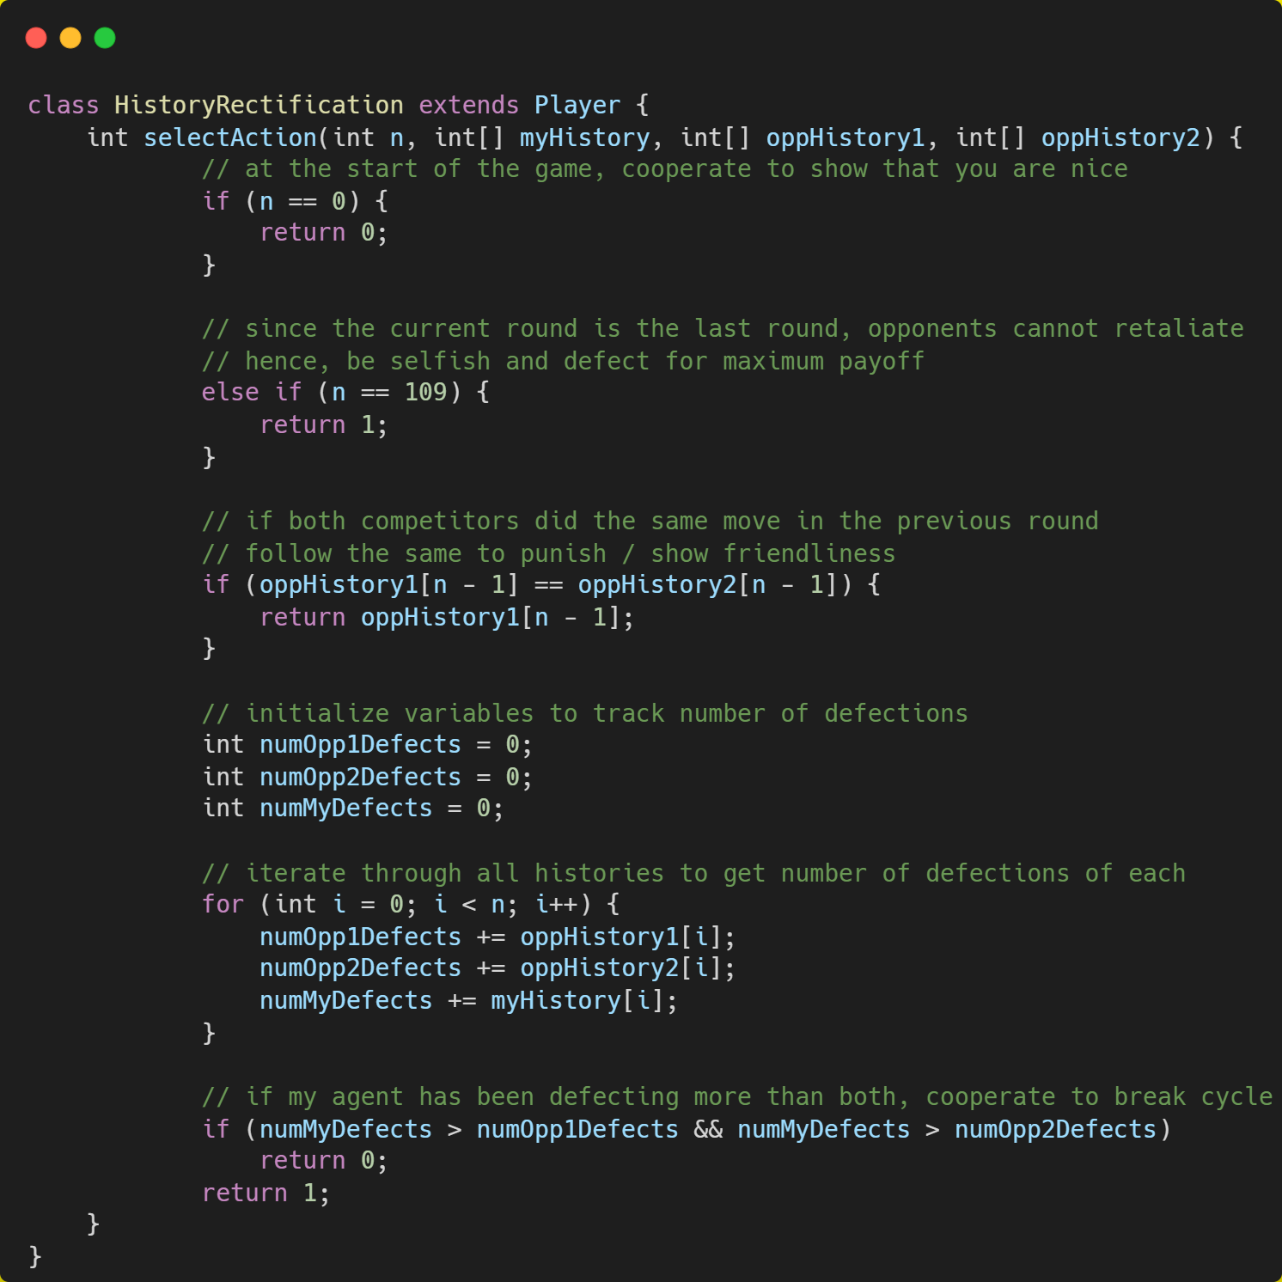
Figure 2. Code for tolerant Tit-for-Tat
The history rectification strategy performed better than NastyPlayer. However, to improve further, the next move was to get the best of both worlds by combining the Tolerant Tit-for-Tat strategy and History Rectification strategy.

Selected Strategy
The selected strategy is a blend of Tolerance and History Rectification with minor optimizations to maximize reward in edge cases. Following are the important components of the implemented strategy:
- In the start of the game, the agent begins with cooperation to show friendliness towards the opponents. This helps to minimize diminishing payoffs in the future rounds that can be caused if opponents become hostile and start defecting. This can be verified from the Payoff Matrix as well.
This follows Axelrod’s suggestion to be nice and start by cooperating.
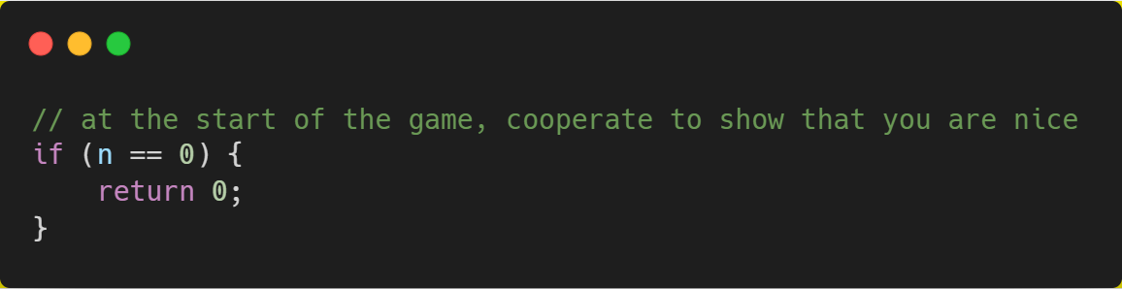
Figure 3. Strategy for start of the game
- If the round number is 109, that is, definitely the last round of the game (since there can only be a maximum of 110 rounds). We know that the opponents cannot retaliate and hence the agent will defect for maximum payoff.
This is a slight tweak to Axelrod’s suggestion since the number of rounds in a game are limited and hence such a selfish move can be taken.
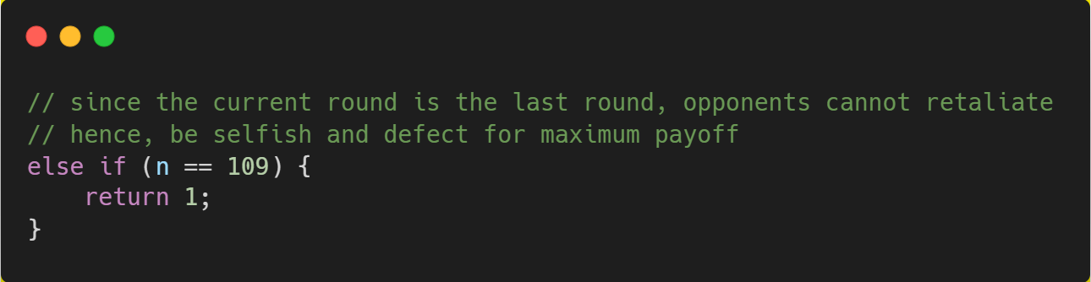
Figure 4. Strategy for end of the game
- Given the histories of both the opponents, if both took the same move in the previous round, reciprocate by following the same move in the current round. Doing this has the advantages as mentioned in the table below:
Scenario | Both opponents cooperated | Both opponents defected
We cooperated | No negative impact as we continue to reward cooperation with cooperation and so should the other rational agents. | We punish the defection of both the opponents by defecting. At the same time, the opponents should be rationally rewarding our cooperation in the previous round.
We defected | There is a possibility that our opponents may now become hostile due to our defection. Hence, to avoid the chain of defections, cooperate to show friendliness. | Punish the defection of opponents in the previous round by defecting again. This also goes to show opponents that further defections cannot be exploited by them for their own gain.
The code for the same is shown in Figure 5 below:
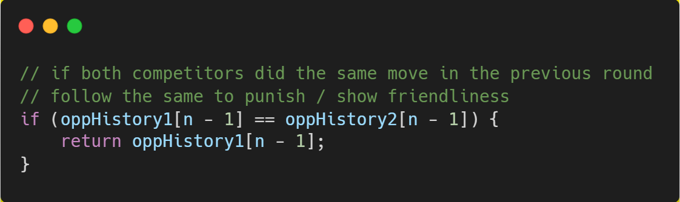
Figure 5. Strategy when both opponents do the same action

- 30% of the times, the agent acts as a Tolerant Tit-for-Tat player. This means that it does not react to the cooperation and defection of each opponent individually. Instead, it considers the number of cooperation and number of defections as a whole. Further, in the tolerant phase, it does not take its own history into account and instead makes decisions solely based on the opponent’s histories.
If the total number of times the opponents cooperated is lesser than the total number of times they have defected so far, then my agent reacts with a defection as a punishment to the opponents as a whole.
If the total number of times the opponents cooperated is greater than the total number of times they have defected so far, then my agent reciprocates the general friendliness of the opponents by cooperating again. This also indicates to the opponents our preference for maximum payoff via friendliness.
The code implementation of this section is shown in Figure 6 below.
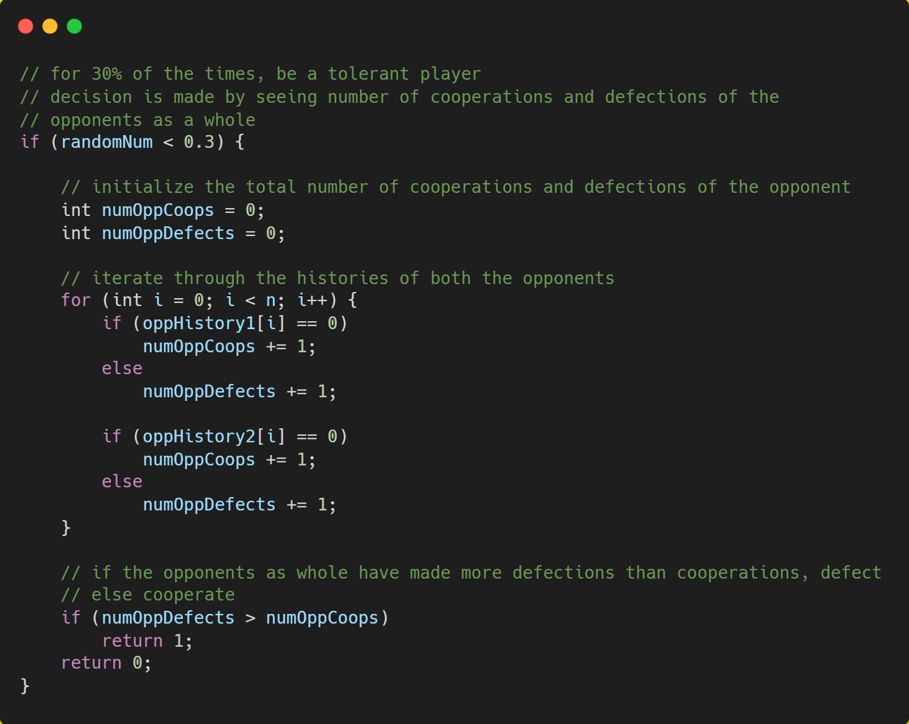
Figure 6. Tolerant strategy for 30% of the time

- However, for majority of the time (70%), my agent takes its history into account as well and takes rectifying steps to decide the action.
If the number of defections of my agent so far surpass that of both the opponents, then it acts as a signal that my agent might be a bit aggressive and hence could lead to more defections from opponents in future rounds due to mistrust and grudges. Hence, it cooperates in the current round. In all other cases, it responds with a defection to punish the opponent who has been defecting more than us.

The code implementation of this section is depicted in Figure 7 below.
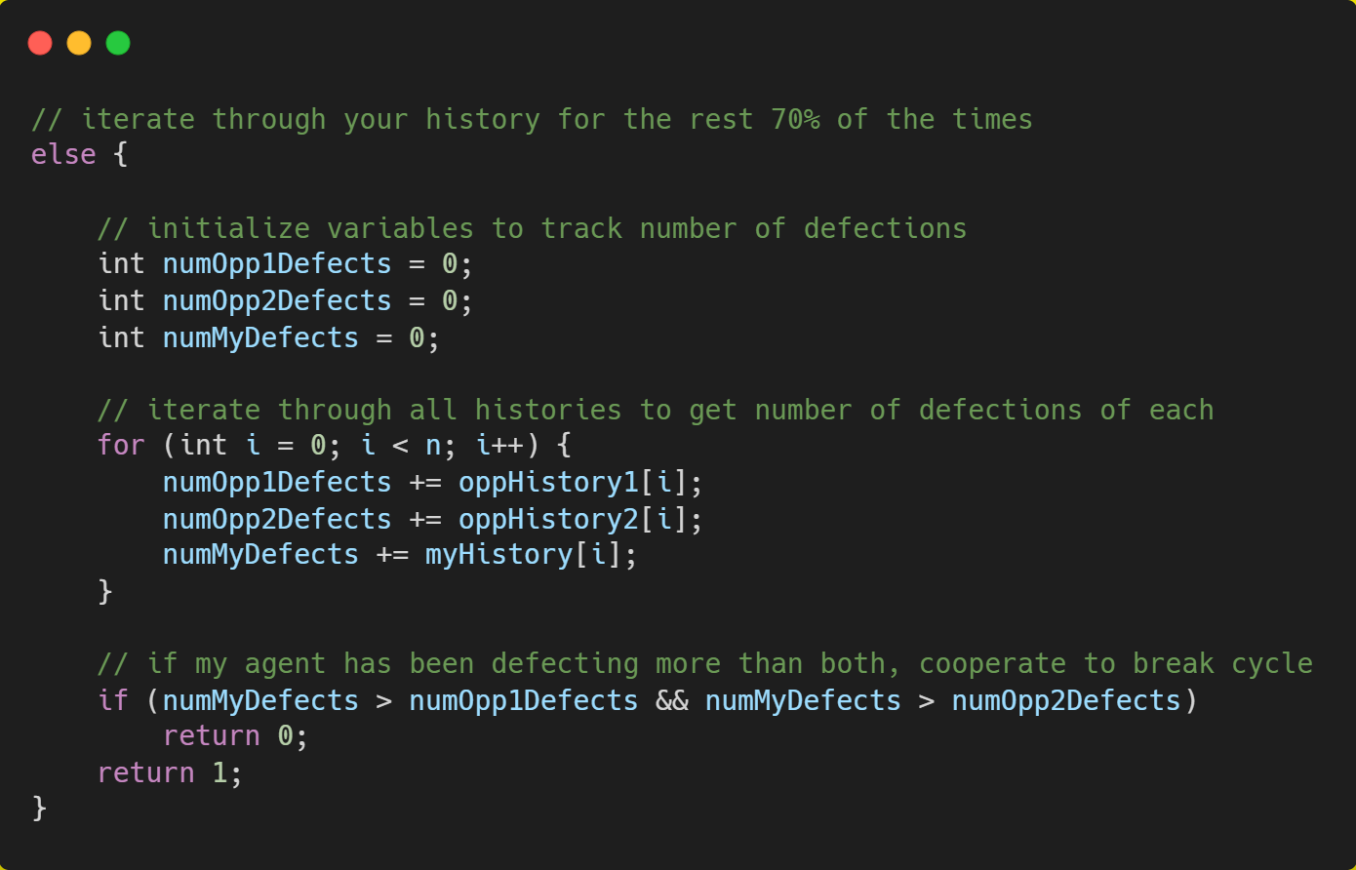
Figure 7. History rectification strategy for 70% of the time

From the above, it is clear that my agent follows Program Equilibria, that is, my agent will be willing to cooperate only if the opponents cooperate. At the same time, it punishes defections using only measured force (does not overdo punishments). This is in line with Axelrod’s suggestions.

Results

Process to judge performance
Since multiple strategies were used, it was essential to average out the performance of the different strategies on a common ground. For this, the provided code template for ThreePrisonersDilemma.java was changed a bit.
Following are important components of the code to judge performance of different strategies:
- A total of 22 different strategies were made to play with each other. This included simple strategies like NastyPlayer, NicePlayer etc.
- The tournament was run 500 times to average out the performance of strategies across tournaments and to generate a more high-level overview of the performance of each strategy in terms of the probability of it securing a particular rank.
After each tournament, the rank of the strategy of interest was recorded in an array ranks. Hence, ranks[i] represented the number of times rank i was obtained.
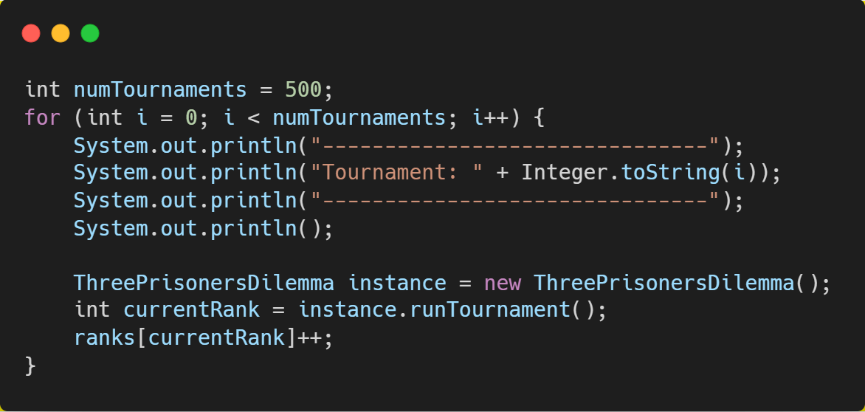
Figure 8. Code snippet to run 500 tournaments
- At the end of the 500 tournaments, the results were displayed on the command line itself. The results stated the probability of the selected strategy (in my case, the strategy selected was Bhatia_Ritik_Player) to secure different ranks.
The probability of obtaining a specific rank i was calculated by dividing the number of times rank i was obtained during simulation, divided by total number of tournaments.
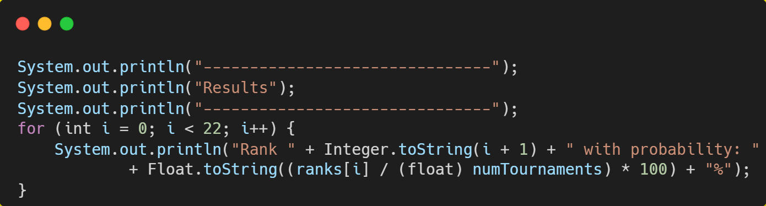
Figure 9. Code snippet to display results after 500 tournaments

Performance of NastyPlayer strategy
The results of the NastyPlayer strategy are shown in Figure 10 below. As can be seen, the results of this strategy are abysmal – it ranked last in all the tournaments (500 tournaments were run), proving that an always defect strategy will not lead to a good ranking during the evaluation process in this assignment.
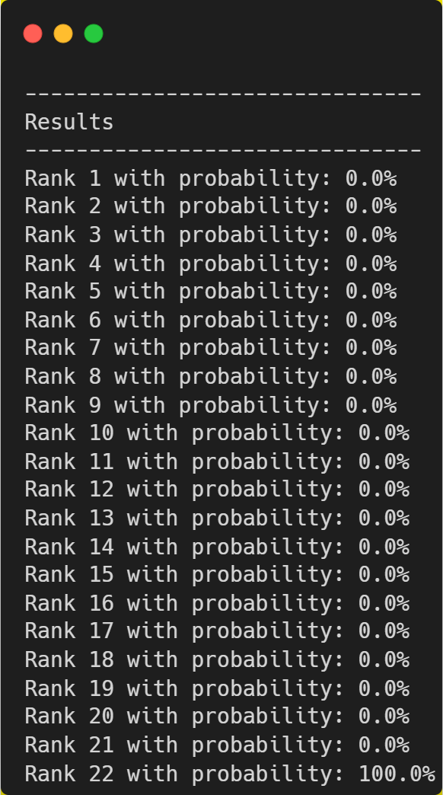
Figure 10. Results for NastyPlayer strategy

Performance of Tolerant Tit-for-Tat strategy
The results of the Tolerant Tit-for-Tat strategy are shown in Figure 11 below.
As is evident from the figure, the results of this strategy are much better than the NastyPlayer, proving that using the qualities of this strategy in the final strategy would be a good option.
The overall results of this strategy are:
- Probability of being in the Top 5: 44.5%
- Probability of being in the Top 10: 81%
The results obtained above are pretty impressive, thereby proving that incorporating Tolerant Tit-for-Tat in the final strategy was a step in the right direction.
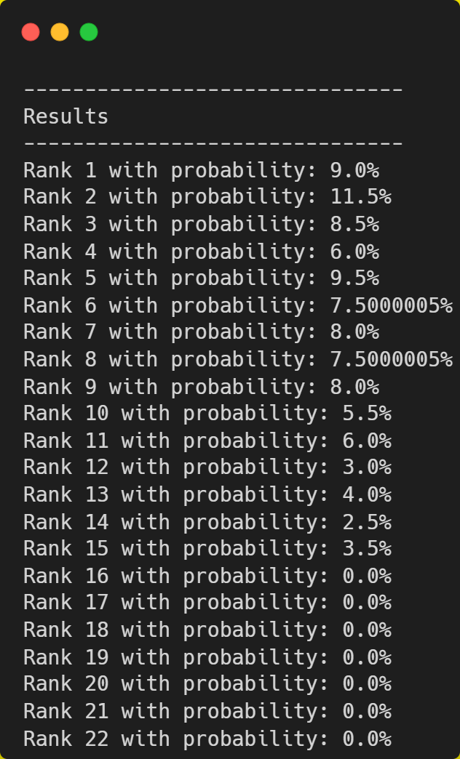
Figure 11. Results for Tolerant Tit-for-Tat strategy

Performance of History Rectification strategy
The overall results of this strategy are:
- Probability of being in the Top 5: 49.5%
- Probability of being in the Top 10: 81.5%
Again, the results of this strategy are very impressive (much better than NastyPlayer and slightly better than Tolerant Tit-for-Tat), proving correct, the decision of incorporating it too.
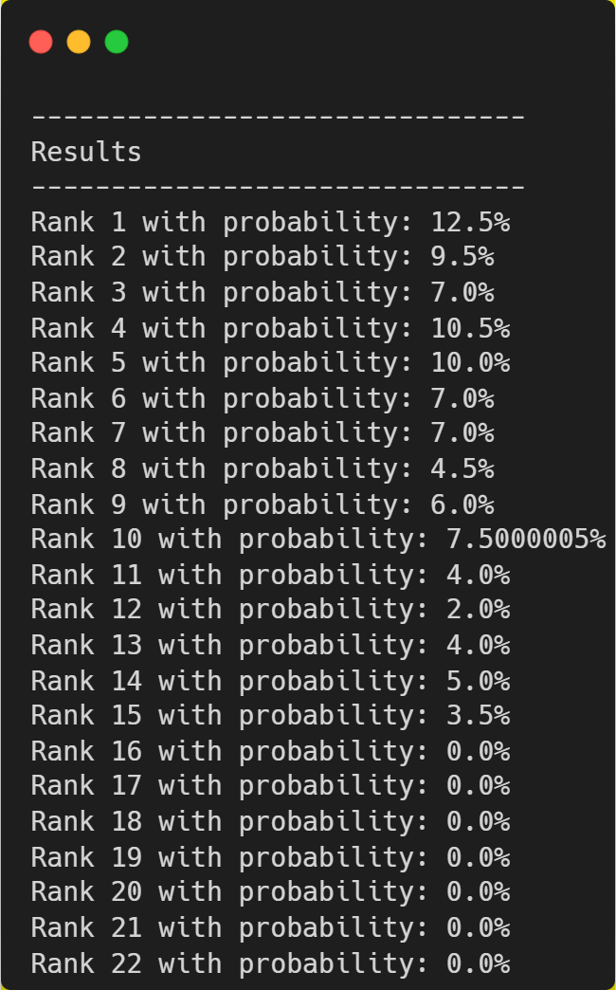
Figure 12. Results for History Rectification strategy

Performance of selected strategy
The performance of the selected strategy was measured by running the custom ThreePrisonersDilemma.java file with the modifications mentioned in section 4.1. above.
The result of one of the tournaments is shown in Figure 13 below. It shows the performance of Bhatia_Ritik_Player strategy against all other strategies (including the example strategies originally provided in ThreePrisonersDilemma.java)
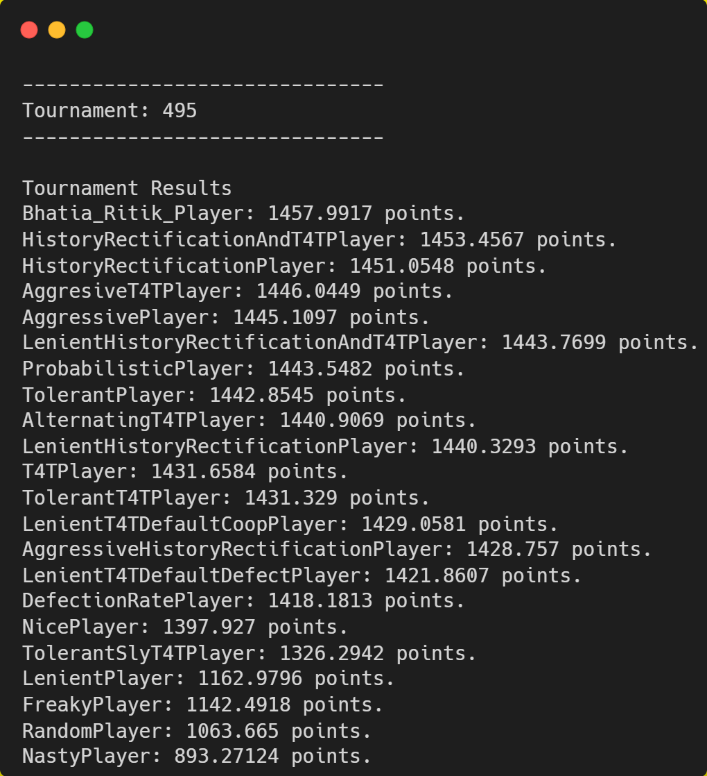
Figure 13. Tournament Results display format

As we can see from results of the last tournament in Figure 13, my agent Bhatia_Ritik_Player performs very well and ends up in the first position. However, this is only a single tournament and not representative of the overall performance of the strategy (since the number of rounds can vary between 90 and 110).
The actual performance of the model can be judged from Figure 14 below. As can be inferred from the same, the average probability of securing a rank in the Top 5 for Bhatia_Ritik_Player is 50.6% and the average probability of securing a rank in the Top 10 is 82.4%.
Although the set of competitor strategies is far smaller than the actual size that will be used for evaluation, it still includes one of the best performing strategies. Further, since there is no strategy that is guaranteed to always produce an optimal result, the performance of Bhatia_Ritik_Player among 22 competitor strategies is decent and hence is a good choice of strategy for submission.
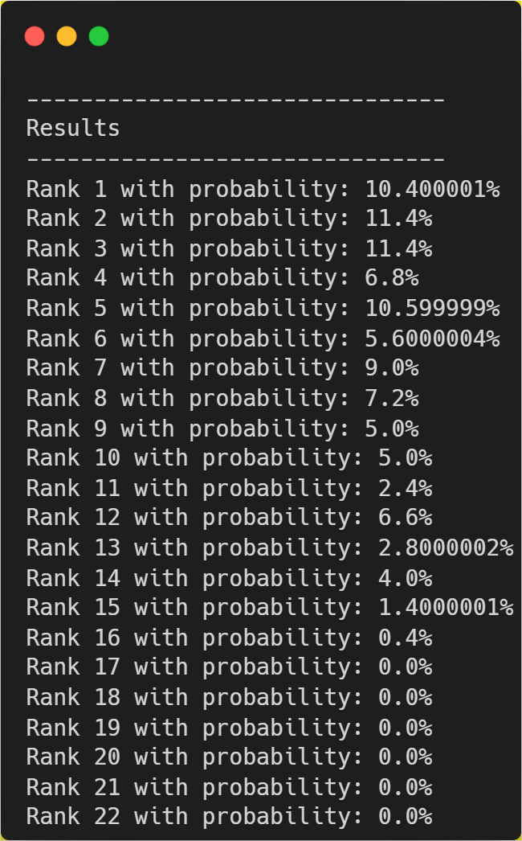
Figure 14. Probability distribution of the rank of Bhatia_Ritik_Player strategy

Another point that can be noted from the results in Figure 14 is that the probability of my strategy securing a lower rank rapidly diminishes to 0 for the lower ranks, which gives further confidence that the strategy can perform well during the actual evaluation.

Conclusion
It is impossible to develop a strategy that can always guarantee a win. This is because of the sheer number of variables and the possibly infinite number of strategies that can be made for this. However, several research studies have performed empirical tests on the most common strategies and their performance evaluation has helped find common characteristics of relatively successful strategies.
For this assignment, the strategy that I have designed aims to build off of commonly successful algorithms with certain tweaks to perform better, given the conditions of the problem. Although securing rank 1 is again not always assured, it is possible to secure a decent rank by factoring in the traits of generic successful algorithms such as Tit-for-Tat and soft majority, as well as the suggestions given by Axelrod for this tournament.
The agent that I have designed for this assignment is a blend of the Tolerant Tit-for-Tat and History Rectification strategies. For the majority (70%) of the time, my strategy actively looks at the history of all the players in the tournament (including itself) and chooses the action that tones down aggression or ups the ante when being too lenient. However, for the remaining 30% of the times, my agent follows a Tit-for-Tat approach irrespective of the actions that it has taken so far.

